Depletion / recovery plug-in
Version 1.0, 5 May 2016
Marta Coll, Jeroen Steenbeek © Ecopath International Initiative
Status: draft

Purpose
The depletion / recovery plug-in collects Ecosim out from a range of EwE models to explore how the ecosystem recovers in the long term after time series perturbations.

User interface
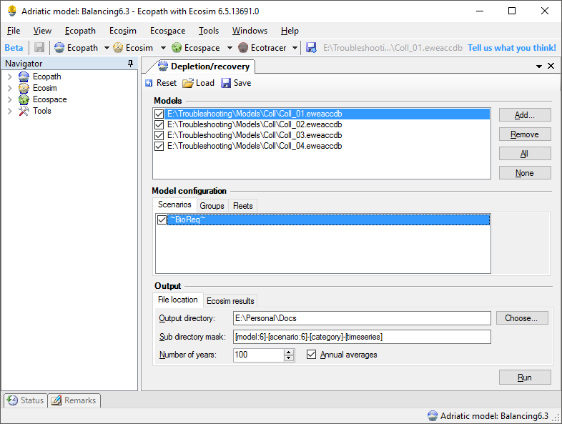
The depletion / recovery plug-in can be activated trough EwE6 > Menu > Tools > Depletion / Recovery…, which will bring up the following screen (Fig. 1):
A
B
C
Figure 1 - The main interface of the Depletion / Recovery plug-in
This screen is organized as follows:

Main toolbar
The toolbar (top) offers the ability to save and load depletion / recovery run configurations. Here users can also reset the plug-in to a pristine layout, erasing all configuration information.

Section A, models
Here users manage which EwE models to run for the analysis. Models can be added by browsing or drag and drop, and models are deleted here. Note that only checked models will be included in the run. Selecting a model will load the model in the EwE user interface and will enable section B.

Section B, model configuration
In this section users manage how a model selected in section A should be executed by the depletion / recovery engine. More details about running will follow below.
First, in the scenario tab, users select which Ecosim scenarios must be executed from the selected model (Fig. 2). Note that only checked scenarios will be included in the run.
Second, in the groups tab, users can assign functional groups to any of the predetermined group categories. A functional group can be member of multiple categories (Fig. 3).
Last, in the fleets tab, users can assign fleets to predetermined fleet categories (Fig. 4).

Section C, output
Here users define which Ecosim model parameters are collected (Fig. 5) and where these results are written to (Fig. 6).
The File Location tab (Fig 6.) allows users to specify an output directory and a subdirectory mask where depletion / recovery results are written to. Underneath the indicated “Output directory” the plug-in will generate a subfolder structure which can designed in the “sub directory mask” field. This field accepts a few keywords listed in table 1. If followed by a colon and a number, keywords will be truncated to indicated number. Please note that keywords do NOT contain spaces!
In this tab users can also specify a custom run length that overrides the settings specified in time series The default depletion / recovery plug-in run length is set to 100 years.

Running the depletion / recovery engine
Schematically, the engine will run the model / scenario / category configuration as follows:
For every enabled model
Load the model
For every enabled scenario
Load the scenario
For every time series dataset
Load the time series dataset
For every category that has functional groups assigned to it
Enable only time series that affect that category
Run Ecosim
Write Ecosim results
Write network analysis results
For every category that has fleets assigned to it
Enable only time series that affect that category
Run Ecosim
Write Ecosim results
Write network analysis results
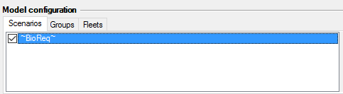  Figure 2 – Selecting scenarios | 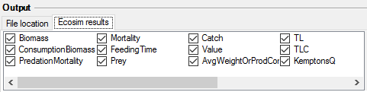  Figure 5 - Configuring which outputs to collect
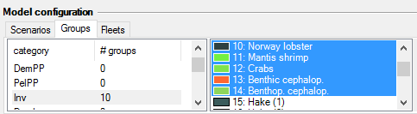  Figure 3 - Categorizing functional groups | 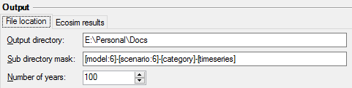  Figure 6 – Configuring output settings
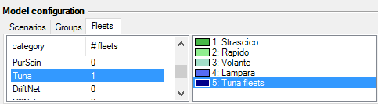
Figure 4 - Categorizing fleets

Table 1 - Supported subdirectory fields
Keyword | Meaning | Examples
model | The name of the model as specified in the Ecopath Parameters form | {model}  {model:10}
scenario | The name of the scenario as specified in the Ecosim Parameters form | {scenario}
category | The name of a group or fleet category as shown in the group and fleet tabs (section B, see Figs 3 and 4) | {category}
timeseries | The name of the time series dataset as specified in Ecosim > Time series | {timeseries}  {timeseries:12}

